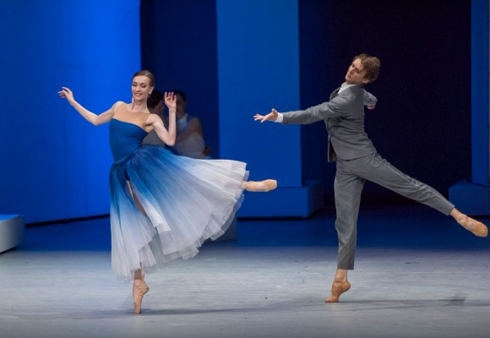
AUDITIONS
LOVE the dramatic blue TUTU on the flyer? Like our costumes for our next contemporary piece!
Do you want to be a part of an fun and dramatic contemporary choreography for the November DanceVisions Performance at Zohar? This dance is inspired by stormy weather and white clouds. Clouds, Wind and Sky is an upcoming contemporary piece by Vicky Brey, music by A. Glazunov. Costumes inspired by the great Bolshoi production of The Taming of the Shrew. Rehearsals are 30 minutes at 7:30 PM on Tuesdays and Thursdays after ballet class (class attendance is optional. Email for more information vickydancevisions@gmail.com
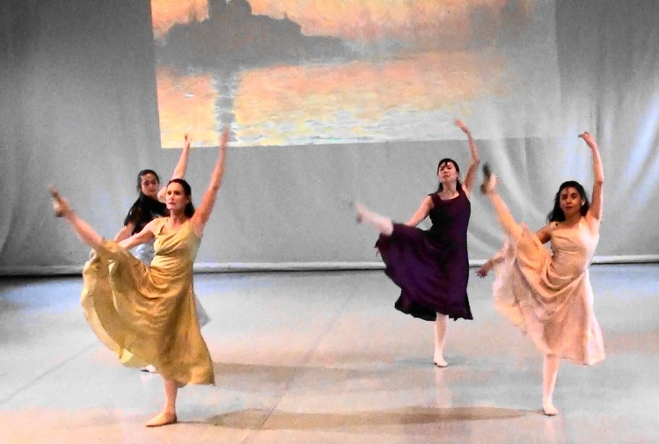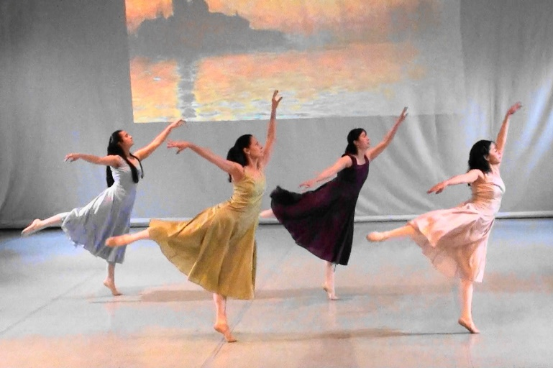
See past choreographies by Vicky on her website www.vickydancevisions.com
Vicky Brey is a teacher of Classical Vaganova Ballet and Contemporary Dance choreographer at DanceVisions.

